Tyler Milne
March 18, 2012
Eng 2010/Kilpatrick

State to State Education

Every year our nation goes through a screening by education week (a United States national newspaper with coverage on grades K-12) to see which state offers the best public education system. All 50 states are individually put through the same test with dozens of factors like teacher quality, financial funding, and student test scores. States are issued a letter grade ranging from A to a F just like students are. The results show that the United States of America come in with a national average of a C. By most standards this means that we are scraping along the bottom with an accumulative score that if below average. The students in Maryland, and Massachusetts received the most merits and come in at the top of the list, while the students in Mississippi and South Dakota hold up the back end with lower test scores than the other states. Why is it that a student attend school in Maryland is more likely to excel in academics when compared to students in Mississippi?
From the article “Maryland schools ranked number one--- again” in The Washington Post by Michael Alison Chandler, Chris Swanson (vice president with editorial projects for Education week) is quoted as saying “Maryland is an example of an all-around strong performer. This state has improving test scores, state policies that support school improvement and comparatively high graduation rates and participation on Advanced Placement tests.” This did not all happen by chance either. Since 2003, Maryland has passed over 10 states on its way to the top. From the same article out of the Washington post the superintendent of schools in Maryland Bernard J Sandusky tells us that the achievement of Maryland ranking number one is due to the states school teachers, and local superintendents. Also declaring that their governor and legislature are committed to education, but still have work to do eliminating racial and socioeconomic disparities in their school program.

FUNDING
Every year the education system grade schools from K-12 are allotted certain amounts of money to fuel schools. The three primary sources of the financing are from the State, Local, and Federal levels. One of the many factors that parents and students look at when considering education is what type, and how much funding the school is bringing in. There are some things that all 50 states are equal in, but educational funding is not one of them. An article from the Huffington Post tells us that in 2009 individual students received $18,126 in New York, and $6,356 in Utah. (Sauter) The ultimate decision as to “how much money will be granted to schools” falls within the jurisdiction of the state. The graph below represent where states get the majority of their money from. With slight variation from state to state.

STATE FUNDING
The greatest contribution in funding education comes from the state each has many professionals working inside their legislature daily to manage and control education funding. Sales and income tax are what states primarily rely upon. State funding is will never be the same for two different state, because it is contingent upon the people living in the state and how much money they are contributing through taxes. The graph below is able to demonstrate the differences from the three highest state funded education systems (New Mexico, Hawaii, and Vermont) versus the three lowest (South Dakota, Nevada, and Illinois). 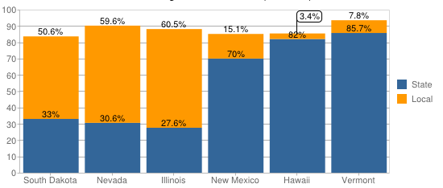
Source: National Center for Education Statistics

LOCAL FUNDING
Funding from the Local government falls slightly behind that of the state with about 40% of the total funds. This funding can either make or break a school districts money flow, because things like property taxes both commercial and residential property taxes. If a school lands in an area that brings in more than average money like Beverly Hills the school district will receive more money than a school in the suburbs of Newark.
FEDERAL FUNDING The federal government accounts for about 10% of the funding that schools receive. The amount is set annually by Congress before the school year begins. In 2011 the amount was 40 billion dollars for all of the schools (K-12) scattered across America. The graph below is a clear visual of what the U.S. government sees as the most important to finance. 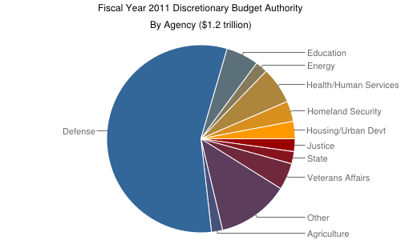

TEACHERS
While in the classroom teachers have the ability to make a large impact on the student. So the question is brought up. Is teacher quality the greatest factor in a students education? In movies like Freedom Writers(2007), Coach Carter (2005), and Gridiron Gang(2006) they take on this case where troubled students in poor neighborhoods who perform poorly with academics are able to change there life and their overall test scores due to one dedicated teacher. As we know movies are not always a reality, so we look deeper for some help.
Education Week claims that by the end of the 2005-2006 school year every teacher working in a public school has to be “highly qualified” in each subject he or she taught. With hopes to give all students the same education benefits no matter what teacher they had.

CONCLUSION

As this country has grown and progressed throughout the decades it has many accomplishments to be proud of. Many major feats concurred like our pronounced freedoms, but at the rate in which we are traveling now our great nation will continue to support aspects that are already well developed and push to the back burner features that will pay off largely in the future. Like that of our succeeding generation of young students.

WORK CITED
Chandler, Micheal A. "Maryland Schools Ranked Number One Again." Education Week. Education Week, 12 Jan. 2012. Web. 3 Mar. 2013. <http://www.washingtonpost.com/blogs/maryland-schools-insider/post/maryland-schools-ranked-number-one--again/2012/01/11/gIQA7NEqrP_blog.html>.

Sauter, Michael B. "State That Spends the Most on Education." Huffington Post. Huffington Post, 3 June 2011. Web. 3 Mar. 2013. <http://www.huffingtonpost.com/2011/05/31/the-states-that-spend-the_n_869398.html#s285461&title=10_Pennsylvania>.

www.febp.newamerica.net

Federal Education Budget Project/Education in the Federal Budget
Published March 22, 2012

Analysis, Background. "Background and Analysis." Federal Education Budget Project. New America Foundation, 5 May 2012. Web. 14 Apr. 2013. <http://febp.newamerica.net/background-analysis/school-finance>.

